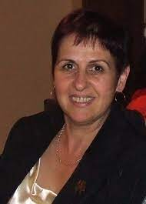

1. Valentina E. Balas

Professor of Automation and Applied Informatics,

Aurel Vlaicu University of Arad, ROMANIA



1. Prof. Xiao-Jun Yang

School of Mathematics,

China University of Mining and Technology, Xuzhou

CHINA

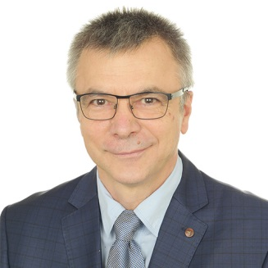

1. Dumitru Baleanu

Professor, Department of Mathematics and Computer Science,

University Ankara, Etimesgut 06790, TURKEY

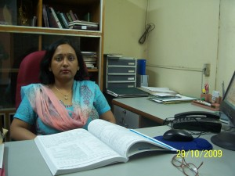

1. Prof. Mani Mehra

Department of mathematics,

IIT, Delhi



1. Prof. Tunde Joseph Taiwo

Department of Physics,

United Arab Emirates University

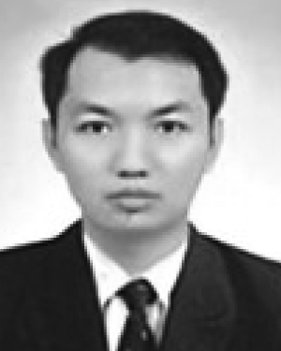

1. Prof. Grienggrai Rajchakit

Maejo University, Thailand



1. Prof. Carla M.A. Pinto

Instituto Superior de Engenharia do Porto Rua Dr. António Bernardino de Almeida, Portugal

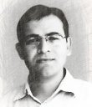

1. Prof. Rajesh Kumar

Department of Electrical Engineering

MNIT, Jaipur

India